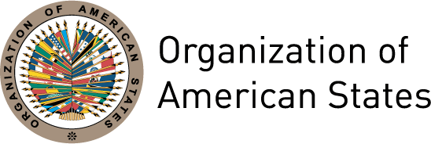

MESSAGE FROM THE SECRETARY GENERAL OF THE ORGANIZATION OF AMERICAN STATES, JOSÉ MIGUEL INSULZA, ON NOVEMBER 25TH, INTERNATIONAL DAY FOR THE ELIMINATION OF VIOLENCE AGAINST WOMEN

November 25th 2012

Washington, D.C.

November 25th is a day on which the International community sets as its main objective the eradication of violence against women. The Organization of American States and its Inter-American Commission of Women (CIM) join in the commemoration of this day, established by the United Nations in order to remind us all of the need to intensify our efforts to fight this scourge.

In this sense, the Secretary General, José Miguel Insulza, highlighted that the OAS - one of whose main challenges, as a regional organ, is the fulfillment of the obligations contained in the Belém do Pará Convention, which establishes a hemispheric commitment to preventing, punishing and eradicating violence against women - “joins the commemorations of this day and recognizes the efforts made by all States that have harmonized their national norms with the provisions of the Convention and have developed plans and mechanisms that aim to eradicate violence against women.”

Notwithstanding, the Secretary General also emphasized that there is still much to be done, and recalled the figures presented during the Ninth Meeting of the Committee of Experts of the Follow-up Mechanism to the Belém do Pará Convention (MESECVI), held this month in Mexico City: 67% of women in the region have suffered some type of violence, including physical, psychological and sexual aggression, and 80% of the victims of trafficking for sexual exploitation are women and girls.

With this in mind, the Secretary General issued an urgent call to Member States to re-double their efforts to generate public awareness, strengthen political will and adopt concrete measures for the prevention and eradication of all forms of violence against women.

Finally, he reiterated the commitment of the Organization to continue working to eradicate the structural inequalities that perpetuate violence and to build more just, equal, equitable and inclusive societies.

